(Approx. 1159 words)

Windows 10 & 11 - Differences in Security, Features, and Looks
By Phil Sorrentino, Secretary, and APCUG Rep, Sun City Center Computer Club
https://scccomputerclub.org/
philsorr (at) yahoo.com
We know Windows 10 is not the last version; maybe Windows 11 will be, but I’m not taking any bets. Technology is constantly changing and usually improving. To say that this is the last of some technology would seem to say that this will be the end of that technology. But Desktop Operating Systems don’t seem to be ending, at least not in the foreseeable future. So desktop/laptop computers need Software to provide control of, and organization, to the underlying computer hardware. Of course, that doesn’t mean it has to be Windows; it could be MacOS, ChromeOS, Linux, Android, or even some yet-to-be-released Operating System that no one has ever heard of. But for my money and my lifetime, I think it will still be Windows. So it probably pays to review and possibly embrace the changes leading to the differences between Windows 10 and 11.
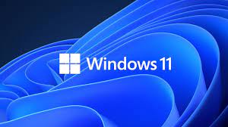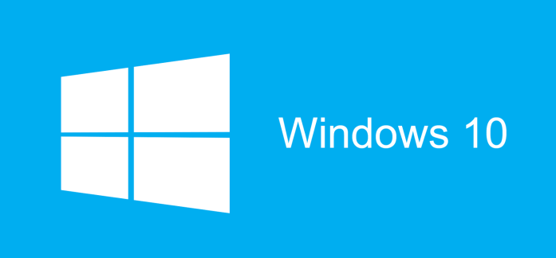
In a nutshell, the differences are in a few specific areas like Minimum hardware requirements, taskbar placement, the shape of the corners of windows, the looks and sounds of activities, the included Apps, and the CPUs it can run on. (A table showing many differences is included at the end of the article.) The performance differences in Windows 11 are pretty much under the hood and come down to how Windows 11 handles system processes that you usually only see when you open Task Manager. According to Microsoft, Windows 11 does a lot of work in memory management to favor the App windows you have open and running in the foreground. Initially, Windows 11 required you to log in to a Microsoft account. Microsoft indicated that that offered benefits such as improved security, better integration with Microsoft’s cloud services, and synchronization between one’s computers. Early adopters provided negative feedback to Microsoft on this requirement, and they removed the need to log in to a Microsoft account, so now you can just set up a local account.
Many things in Windows 11 look different, but many perceived differences are not in the functionality provided but where to go to find the functionality. Once you get there, you find that it works just the way it did in Windows 10. You’ll probably notice one minor difference, “Command Prompt” is now “Windows Terminal.” Features in Windows 11 now look more like Apps, though they have not really changed what they do or how they do it. There is a button on the Start screen, right above the “Pinned Apps” called “All apps,” a term from the mobile device world. Some things are very much the same; right-click the start button in either OS, and you’ll find a similar list of features (though Mobility Center is now added to the Windows 11 list). If you use the Action Center, you will notice it is not on the taskbar. The Winkey+A keyboard shortcut will provide similar information without notifications. Notifications can be found in Settings-System. Control Panel is still around; search for it using the “Search” icon on the taskbar, which leads you to the “Quick Assist” window. When you open the Control Panel App, you will see just what you remember from Windows 10, minus Administrative Tools, but plus Windows Mobility Center and Windows Tools. And oh, if you feel that you will be happier with the start button on the left, go to Settings-Personalization-Taskbar and click on “Taskbar behaviors” and finally pull down the arrow next to “Center” and choose “Left” as the Taskbar alignment.

Possibly, the main difference between Windows 10 and Windows 11 is security. Windows 11 requires a PC that’s capable of Secure Boot, which prevents malware from attacking the boot process. (You don’t have to enable Secure Boot, but the PC must support it. It seems inevitable that it will soon have to be enabled.) And your PC must have a Trusted Platform Module (TPM) version 2.0 hardware chip to manage cryptographic keys and protect your PC’s OS and firmware. TPM is usually a dedicated chip on a motherboard that provides hardware encryption for features like BitLocker and Windows Hello. Without these two security components, Secure Boot and TPM, you will probably have to stay with Windows 10. The concept of a Trusted Platform Module goes back around 20 years, and PCs have had them since 2005. (Microsoft’s BitLocker, a whole-drive encryption system, relies on the TPM hardware to manage and protect its cryptographic keys. Windows Hello face recognition also makes use of TPM support. (Microsoft’s documentation advises that any modern PC probably has a TPM and that any PC less than five years old most likely has the latest version of the TPM hardware, 2.0.) TPM is critical to security. It validates hardware and software components, so no one can tamper with your PC. It stores important cryptographic keys and supplies ultra-secure cryptographic functions to Windows and many applications. All this considered, it looks like a major difference is that Windows 11 provides improved computer security.
As an aside, Apple’s OSs have had security baked into them from the start. The mobile OS, iOS, is even more locked down than the desktop OS, MacOS. Windows, on the other hand, is still in the process of locking down many system vulnerabilities. By requiring Secure Boot and a TPM 2.0 chip, Windows 11 will eliminate a whole class of malware attacks that gain control over the computer by subverting the Windows boot process or getting into the system before bootup. Unfortunately, some older PCs will be left behind in making the jump to a more secure Windows 11, but Microsoft has said that it will maintain Windows 10 for at least the next two years. Hopefully, the increased security will be worth the inconvenience and cost of upgrading to Windows 11.

Feature | Windows 10 | Windows 11
Release date | 2015 | 2021
Minimum hardware | 2GB Ram, 32GB Storage | 4GB Ram, 64GB Storage
Trusted Platform Module | 1.2 | 2.0
Can run Android Apps | No | Yes
Start Menu | On the Left | In the Center (Can be moved)
End of Life | Oct. 2025 | ???
Snap Layouts | Minimal | Improved and easy to use
Virtual Desktops | Taskview | Improved –Similar to Mac
Taskbar -Location | Top, bottom, side | Bottom, center (or left)
Taskbar –Open Apps | All the same | Wide bar –App with focus
Windows | Sharp corners | Rounded corners –Softer look
Sounds | Yes | Muted –Light/Dark mode differ
Action Center | Yes | Changed
File Explorer | Yes | Improved
Browser Included | Internet Explorer, Edge | Edge
Snipping Tool | And Snip & Sketch | Only Updated Snipping Tool
Tablet mode | A Choice | Automatic when keyboard removed
Tablet Gestures | Yes | Multi-finger gestures added
Touch, Pen, Voice Input | Yes | Improved
Widgets | Yes | Improved –Slideout screen
32-bit version of OS | Yes | Not available
Feature Updates | Twice a year | Once a year
Startup Menu | Large Live Tiles | Grid of App Icons
On-Line Communications | Skype | Teams
Cortana Setup | Included | Eliminated

